

up.time agent modification for java processes

Executive Summary
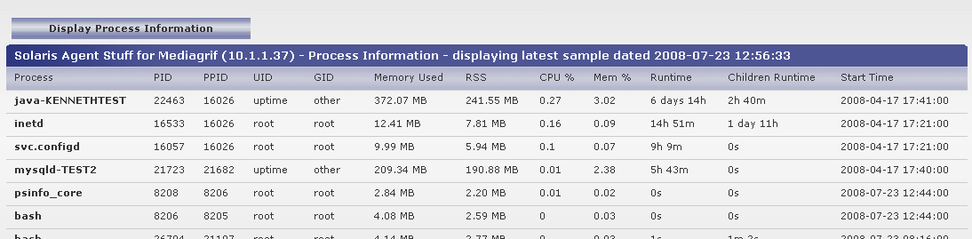
Up.time currently reports all java processes as simply java in the process list. This agent modification will allow the agent on machines that are equipped with Java servers to parse through a list of server processes and names and append that to the information being sent to the up.time monitoring station.

Because on certain platforms the packaged standard uptime psinfo directive is a binary file, this solution utilizes a script wrapper to ensure that the correct translation of java process names occur.

Prerequisites
You must be using a POSIX based version of the uptime agent on the target host.

Installation Target
This modified agent is only required on servers where you wish to be able to establish unique java process id’s within the up.time monitoring tool.

Package Installation
Included in the file package delivered with this document is a file called psinfo. To install this package copy the files to the uptime agent binaries folder by performing the following steps.

Assuming the agent installation folder is /opt/uptime-agent/

- Copy the existing psinfo script to a file called psinfo_core in the bin folder (i.e /opt/uptime-agent/bin)
- Copy the new package in the attached archive into the bin folder so that it now is in the same folder as the copied psinfo_core
- Change the owner of psinfo to nobody and the file permissions to be sufficient to execute the script
- Validate all paths in the psinfo wrapper script that point to /opt/uptime-agent/tmp and /opt/uptime-agent/bin are valid based on your installation paths.

You are now ready to proceed to validation.

Package Validation
To verify that the package has been delivered successfully execute the following on the shell in the folder /opt/uptime-agent/bin

./psinfo 20

If your output looks like the following you have successfully installed the agent modification

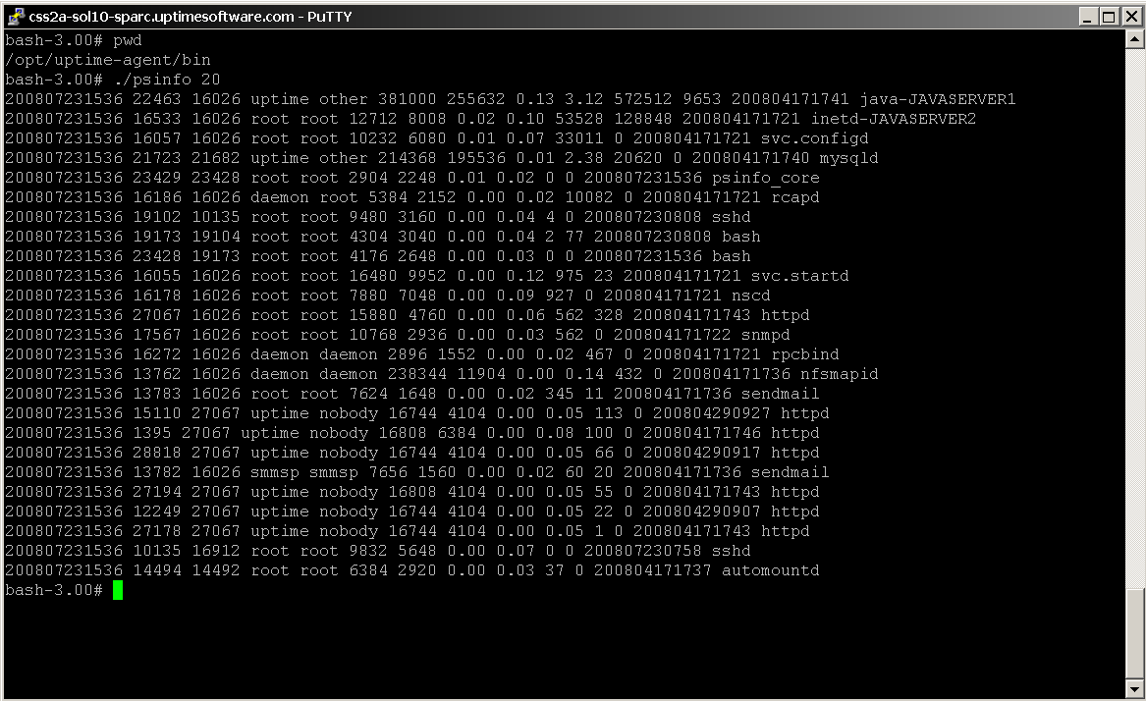

Troubleshooting

- Validate where the problem is – in the included file archive there is a file called javaid.txt place this in the tmp directory in the agent folder i.e /opt/uptime-agent/tmp
  - Comment out the line in the file psinfo
  - Re-test the script using the steps in the validation section of this document.
If the script executes, then this validates that there is a problem with the script that generates the javaid.txt file. Please refer to the included javaid.txt file and ensure that the script in psinfo is correct for generating the corresponding file output for java pids on the target servers.

The script in question is the following line in psinfo:

for fn in /home/*/servers/*pid /home/*/tsc/.*pid; do sn=`basename $fn | sed -e \'s/^\.//;s/\.pid$//\'`; echo `cat $fn ` $sn; done > /opt/uptime-agent/tmp/javaid.txt

Change Log

Contributor Date Description
Kenneth Cheung 07.23.2008 Creation/Review
Joel Pereira 06.21.2011 Update/Clean

